**“SENSING HARMFUL GASES IN INDUSTRIES USING IOT AND WSN”**

A Project Report Submitted in the partial fulfillment of requirement of the Degree of

Bachelor of Engineering

in

Computer Technology

Rashtrasant Tukdoji Maharaj Nagpur University, Nagpur

Under the guidance of

**Guide Name – Mrs. Snehal Golait**

Submitted by

**RISHIKESH KUMAR**  **AJINKYA GHADOLE** **TWINKLE PANDEY KOMAL PANDEY** **SAMIKSHA YERPUDE**



DEPARTMENT OF COMPUTER TECHNOLOGY

PRIYADARSHINI COLLEGE OF ENGINEERING, NAGPUR-440019

**2019-2020**

VISION OF INSTITUTE

To become one of the India’s leading engineering institutes in both education & research. We are committed to provide quality & state of the art technical education to our student, so that they become technologically superior & in turn contribute for creating a great society.

MISSION OF INSTITUTE

We commit ourselves to the pursuit of excellence in technical education & promise to uphold the spirit the spirit of professionalism to serve humanity.

VISION OF DEPARTMENT

To excel in creating outstanding academicians and technocrats for valuable contribution to the society and computer engineering field worldwide as per the ever changing needs.

MISSION OF DEPARTMENT

To ensure technical proficiency to meet industrial needs.

To impart ethical and value based education for social cause.

To encourage the students for carrying out research activities and lifelong learning.

**PRIYADARSHINI COLLGE OF ENGINEERING**

**Department of Computer Technology**

NAGPUR-440019

**CERTIFICATE**

This is to certify that project report entitled - **“Sensing Harmul Gases in Industries using IOT and WSN”** is a bonafide work done by the student **RISHIKESH KUMAR ,AJINKYA GHADOLE , TWINKLE PANDEY , KOMAL PANDEY and SAMIKSHA YERPUDE .** The project report is submitted to **Rashtrasant Tukadoji Maharaj Nagpur University, Nagpur** in partial fulfillment of the requirements for the degree of **Bachelor of Engineering in Computer Technology.**

**Session 2019-2020**

**GUIDED BY- Mrs. Snehal Golait**

Dr. N.M. Thakare Dr. M.P. Singh

H.O.D, Computer Technology, P.C.E. Principal, P.C.E.

**PRIYADARSHINI COLLGE OF ENGINEERING,**

**NAGPUR-440019 (INDIA)**

**Department of Computer Technology**

**DECLARATION**

We, the undersigned, declare that the project entitled **“Sensing Harmul Gases in Industries using IOT and WSN”,** being submittedin partial fulfillment for the award of Degree in Computer Technology, affiliated to RASHTRASANT TUKDOJI MAHARAJ NAGPUR UNIVERSITY, is the work carried out by us.

**Place: NAGPUR PROJECTEES: -**

**Date: 25.04.20 RISHIKESH KUMAR**

**AJINKYA GHADOLE**

**SAMIKSHA YERPUDE**

**TWINKLE PANDEY**

**KOMAL PANDEY**

**ACKNOWLEDGEMENT**

It is our pleasure to acknowledge our sincere thanks with a deep sense of gratitude towards our project guide “Mrs. Snehal Golait**”**, Assistant Professor, Computer Technology Department for her continuous knowledge and support in conducting this dissertation work. She has a whole heartedly helped us in this endeavor at all stages of this work.

We are thankful to **Dr. M.P. Singh**, Principal, Priyadarshini College of Engineering, Nagpur, for providing the facilities at the institute.

We thank **Dr. N.M. Thakare**, Professor and Head of Computer Technology Department of Priyadarshini College of Engineering, Nagpur.

We herewith express our immense thanks to **“**Mrs. Snehal Golait**”, Assistant Professor**, Assistance Professor, Computer Technology Department, Priyadarshini College of Engineering, Nagpur for giving us suggestions and co-ordination with us from time to time as the project in charge.

We also take the opportunity to thank all, who have directly or indirectly extended help and encouragement in executing this project.

**PROJECTEE:**

**RISHIKESH KUMAR**

**AJINKYA GHADOLE**

**SAMIKSHA YERPUDE**

**TWINKLE PANDEY**

**KOMAL PANDEY**

**INDEX**

**CHAPTER 1: INTRODUCTION**

**CHAPTER 2: LITERATURE REVIEW**

**CHAPTER 3: OBJECTIVES**

**CHAPTER 4: ARCHITECTURE**

**CHAPTER 5: ALGORITHMS**

**CHAPTER 6: DATA FLOW DIAGRAM**

**CHAPTER 7: MODULES**

**CHAPTER 8: SCREENSHOTS**

**CHAPTER 9: SOFTWARE REQUIREMENTS**

**CHAPTER 10: CODING**

**CHAPTER 11: APPLICATION AREA**

**CHAPTER 12: FUTURE SCOPE**

**CHAPTER 13: CONCLUSION**

**CHAPTER 14: REFERENCES**

**PAPER PUBLISHED , CERTIFICATES & POSTER**

##### TABLE OF CONTENTS

##### Chapter No. Title Page No. ABSTRACT

##### LIST OF TABLES xvi

##### LIST OF FIGURES xviii

##### LIST OF SYMBOLS xvii

##### INTRODUCTION 1

|  |  |  |  |
| --- | --- | --- | --- |
| 1.1 | GENERAL | | 1 |
| 1.2 | . . . . . . . . . . . . . | | 2 |
| 1.2.1 General 5 | | | |
|  | 1.2.2 | . . . . . . . . . . . | 12 |
|  |  | 1.2.2.1 General | 19 |
|  |  | 1.2.2.2 . . . . . . . . . . | 25 |
|  |  | 1.2.2.3 . . . . . . . . . . | 29 |
|  | 1.2.3 | . . . . . . . . . . . . | 30 |
| 1.3 | . . . . . . | . . . . .. . . . . . . | 45 |
| 1.4 | . . . . . . | . . . . . . . . . . . . | 58 |

**2. LITERATURE REVIEW** 60

**CHAPTER 1**

**INTRODUCTION**

**1.1 Introduction**

Hitherto, research and development activities pertaining to gas sensing devices has gained a rigorous momentum across the world.

***“****The detection of LPG/CNG gases has become a main issue due to more**wellbeing policy wide-reaching.****”***

These sensors can be used for various applications, e.g. monitoring and controlling of the explosive level of concentration of gases, finding of various harmful, dangerous, toxic gases, industrial automation etc. In recent years, the biggest advancement made in the sensor tools is the detection of liquefied petroleum gas and has become tip of the iceberg because outburst accidents force to be happened when it leaks excessively. Therefore, the research work particularly, in the area of wireless sensor network and earlier gas leakage detection (alert system) is imperative.

The monitoring, reorganization and controlling of the data are the key concern of Wireless Sensor Network. The inaccessible interface and actual monitoring with the physical world can be done easily by mote of the network. The wireless sensor networks differ from general data networks, because WSN are application oriented, planned and deployed for dedicated purpose. The wireless sensor network provides extensive range of the applications such as in green monitoring, defense, health, etc [1,2,3].The litheness in plan, enhanced mobility, consistency, broadcast range, reduced power, cost-effective etc are the good features of these network [1,3,4]. Additionally, the system uses the ZigBee technology for wireless communication. This technology is most trustworthy and apposite for interior and outdoor applications. The ZigBee can be configured in star, mesh or peer to peer topology. A demanding subject in scheming WSNs is inadequate power supply for sensor nodes in some application. The breakdown of a mote results in degradation of the entire network. The preference of a topology can play an imperative role in reduction of power consumption.

The present system is mainly used for the detection of LPG gas. If gas leakage happens at certain place, the present system detects the LPG gas alerts the peoples by buzzering and sending SMS on users mobile phone using arduino GSM shield compatible to the arduino board [5, 6]. The monitoring of the sensor node can be done using G-code created in LabVIEW. The current system provides genuine instance notifications. This system can be installed in a place where LPG is used as a fuel and leakage happens instantly. The present wireless gas detection system plays imperative role model to industry as well as general public.

**1.2 The Fundamentals of Sensors**

A sensor is a device which converts physical quantity into electrical quantity. The human body which can’t sense any quantity can be done easily by commercial sensors like temperature, humidity, intensity etc. Any input signals given to electronic instruments, detection of it and convert them into appropriate output signal, the sensor does it entirely. Nowadays, sensor becomes omnipresent in our regular routines. The properties of sensors are:

* Convert the non-electrical quantity into electrical quantity
* Take action speedily
* Function incessantly
* Portable.
* The sensitivity
* The stability associated with it.
* How repeatability it has.

**1.2.1 The categorization of sensors**

Sensors are categorized according to their conversion property (Fig.1.1). The various sensors according to their properties are classified in physical and chemical category.

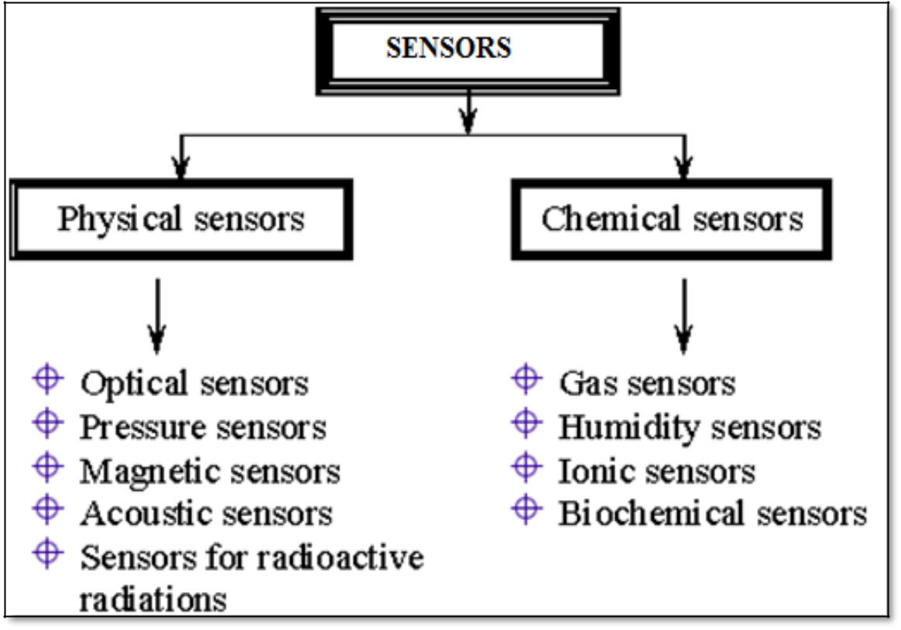

**Fig. 1.1. The categorization of sensors.**

The different pioneering technology has been used to make the sensor cost effective.

**1.2.2 The importance of gas sensors**

In the existing scenario, the gas sensors are leading the way from home monitoring to industry monitoring. The gas sensors are indispensable for various applications such as monitoring of various environmental parameters, detection of toxic gases etc. There are different semiconductor gas sensors available in the market having got outstanding position, seeing that they are speedy, consistent, cost-effective and bare minimum maintenance. Hitherto, ceramic gas sensors were used for detection of gases. The gas sensors are mainly oxidizing and reducing in nature. Whereas oxidizing sensors results in the creation of acceptor states and the reducing sensor results in donor states. The resistive, potentiometric and amperometric sensors [7, 8] are most sensitive sensors.

**1.3 The Necessity for Gas Sensors**

The olfactory system of humans is outstanding for the recognition of odours which can be observed merely at towering concentrations or can’t detect at all [7]. For the protection of human life, to take preventive measure against the explosive concentration of gases and for poisonous gas applications, a gas sensor is essential for the detection of gas in low concentration range. To prevent the gas leakage that happens at homes, industries etc, detection of various gases at low concentration is possible only due to gas sensors. Hence, gas sensor becomes the part and parcel of today’s life.

**1.4 The Liquefied Petroleum Gas (LPG)**

The Liquefied petroleum gas (LPG) has no colour and no smell. The LPG gas liquefies under moderate pressure and vapourize upon discharge of pressure. Therefore, the LPG is stored in liquid form (concentrated). In general, LPG obtained from sanitized crude oil, in this way, it is under pressure form [7] and also from natural gas or crude oil streams. The LPG can be odorized by adding an appropriate odour for the prevention of explosive attacks. The most important property of LPG is that, it is heavier than air. As concentration of LPG increases, it creates hazards to human health [8]. The LPG can be used as a fuel for many sectors, viz. domestic, industrial, cooking processes etc. LPG is also used as a fuel for vehicles [9].

Due to the flammable behaviour of LPG gas, out of harm's way handlings of LPG must be useful in the domestic and industrial situations. Its liquid form is very harmful for the skin [10]. Therefore, to avoid the hazards from this, monitoring and controlling of LPG leakage is carried out through this thesis.

**CHAPTER 2:**

**LITERATURE REVIEW**

To work against the dangerous effects of gas leakage, significant efforts was carried out in manipulative and miniaturizing the gas leak sighting technique. The occurrences of gas leak-related incidents are studied by several researchers and have published statistical data incidents. In 2012, Somov et al [11] reported “Energy-Aware Gas Sensing Using Wireless Sensor Networks” focusing on a sensor node, a relay node, a wireless actuator and a network coordinator. The network coordinator is the main unit of the WSN. It supports the network operation by wireless communication based on the IEEE 802.15.4 standard and the ZigBee specifications. The network coordinator is also responsible for alerting a network operator or an emergency service using the Ethernet network or sending a SMS using a GSM/GPRS modem. In fact, upon receiving the alert message from the sensor node, the network coordinator can perform the first counter action by deactivating the source of gas emission via the wireless actuator [11].

In 2011, Bhattacharjee et al [12] designed a system entitled “Design and Development of a Flexible Reliable Smart Gas Detection System”. The system composed of three modules; the base station, wireless sensor array and an intelligent wireless alarm unit, which offers high reliability, flexibility and uninterrupted sensing. These are achieved by incorporating various intelligent protocols like auto sensor calibration, sensor handover, wireless threshold fixation and intelligent alarm mechanism. The sensor node consists of three gas sensors, one temperature sensor and one pyro-electric infrared sensor (PIR) which enhances the sensing intelligence. The sensed data are digitized and processed by the peripheral interface controller (PIC) 16f877A based centralized embedded.

platform and wireless communication is achieved with a pair of 433 and 315 MHz amplitude shift keying (ASK) wireless module. The encoding and decoding of sensed data offer a high secured gas detection system [12].

Ya et al [13] pointed out an “Intelligent Residential Security Alarm and Remote Control System Based on Single Chip Computer”. Their work focused on the intelligent residential burglar alarm, emergency alarm, fire alarm, toxic gas leakage remote automatic sound alarm and remote control system, which is based on 89c51 single chip computer. The system can perform an automatic alarm, which calls the police hotline number automatically. It can also be a voice alarm and shows alarm occurred address. This intelligent security system can be used to control the electrical power remotely through telephone [13]. Peijiang and Xuehhua [14] developed a system namely “Design and Implementation of Remote Monitoring System Based on GSM”, which has focused on the wireless monitoring system; a remote monitoring system based on SMS through GSM. The hardware and software architectures of the system are designed. In this system, the remote signal is transmitted through GSM network. The system includes mainly two parts; the monitoring centre and the remote monitoring station. The monitoring centre consists of a computer and a TC35 communication module for GSM. The computer and the TC35 are interfaced by RS232. The remote monitoring station consists of a TC35 communication module for GSM, a MSP430F149 MCU, a display unit, sensors and a data gathering and processing unit. The software for the monitoring center and the remote monitoring station were designed using Visual Basic [14].

A low cost automotive localization system using GPS and GSM-SMS services was proposed by Lita et al [15]. It is concerning “A New Approach of Automatic Localization System Using GPS and GSM/GPRS Transmission”, which provides the position of the vehicle on the driver’s or owner’s mobile phone as a short message (SMS).

The system can be interconnected with the car alarm system that alerts the owner, on his mobile phone, about the events that occurs with his car when it is parked. The system is composed by a GPS receiver, a microcontroller and a GSM phone. In addition, the system can be settled for acquiring and transmitting the information, whenever requested about automobiles status and alerts the user about the vehicle’s started engine. The system can be used as a low cost solution for automobiles position localizing as well as in car tracking system applications [15].Investigation on vehicle cabin air quality monitoring system with metal oxide semiconductor gas sensor was the breakthrough in this field by Galatsis et al[16]. Herein, commercially available gas sensors are compared with the fabricated M0O3 based sensors. The sensor has a response of 74% or higher relative to the host commercial sensor tested [16]. The same authors have also contributed to the added vehicle safety through a vehicle cabin air quality monitor using carbon monoxide (CO) and oxygen (02) gas sensors system designed, developed and on-road tested [17]. The continuous monitoring of oxygen and carbon monoxide provides added vehicle safety as alarm could be set off when dangerous gas concentrations are reached, preventing driver fatigue, drowsiness and exhaust gas suicides. CO concentrations of 30 ppm and oxygen levels lower than 19.5% were experienced whilst driving.

A “GSM Based Gas leakage Detection System” by Srivastava and Prabhukar[18] provides a cost effective and highly accurate system, which not only detects the gas leakage but also alert and turn off the mains power and gas supplies and sends a SMS. Rammaya and Palaniappen [19] reported an “Embedded System for Hazardous Gas Detection and Alerting”. The alerting of gas leakage is through buzzer and SMS. A“WSN based Smart System for Detection of LPG and Combustible Gases” has been proposed by Hema et al [20],which identifies potentially hazardous gas leak within an area by means of various sensors based electronic systems. These systems also employ an audible alarm to alert the people whenever a dangerous gas is detected. These gas detection systems are of immense use because they can be used to detect a wide range of combustible, flammable and toxic gases which have hazardous effects on human health [20]. ”Design Implementation of an Economic Gas Leakage Detector” by Mahalingam et al provided a cost effective audio-visual solution for LPG leakage detection in homes and commercial premises and audibly alert the users in case of a hazardous situation and provide warning signals (beeps) [21].

**CHAPTER 3:**

**OBJECTIVES**

The objectives of this research work are to design, as well assemble and test a dynamic system that can detect the presence of natural and combustible gases and send an SMS alert to the user and nearest disaster management if gas leakage occurs. The dynamic system makes mainly the use of Wireless Sensor Network (WSN). The step programs that would be undertaken are as follows.

1. To analyze a gas sensor for the detection of liquid petroleum gas (LPG).
2. To establish the WSN nodes for gas leakage detection using Arduino nano microcontrollers with XBee.
3. To study the salient features of ZigBee RF module and develop a suitable code for it using X-CTU IDE.
4. To develop a dynamic system that can detect and control the gas leakage and monitor automatically using LabVIEW.
5. Designing of the system will be such that it will be able to send SMS alert to the users.

Taking the above survey into account, we are proposing a system which will be able to detect and also control the gas leakage. In addition, it will be able to alert by buzzer and should send an SMS. In addition, monitoring of the system (wirelessly) would be easy and displayed on the internet using the URL obtained from the web publishing tool. LabVIEW. The interface of the data monitoring with internet server will provide an additional advantage to the users for monitoring the gas leakage area at the long distance continuously.

We planned for a multistep research program and the actual quanta of the work that has been carried out is divided into six chapters.

Chapter I mainly reviews the general concepts and some issues of wireless sensor networks. This chapter includes basics of wireless sensor networks and issues related to wireless sensor networks such as energy efficiency, localization and routing strategy for the deployment of sensor nodes. A detailed literature survey on the development of gas leakage detection and alert system and their applications are also given in this chapter.

Chapter II starts with the discussion of hardware implementation of wireless sensor node and includes details of microcontroller unit and its features. The calibration of wireless sensor node using gas chamber is described in detail. The design and development of PCB and co-ordinator node are discussed.

Chapter III concerns the details of technological platforms and development tools required for a wireless gas sensing system. The details regarding the development of firmware for wireless sensor node with arduino IDE, LabVIEW is also discussed. The programming and flowcharts of wireless gas sensing system are also described in this chapter.

Chapter IV gives detailed studies regarding implementation of wireless system to monitor and control the LPG gas leakage. Designing of the graphical user interface, in LabVIEW environment, is also discussed. The necessary circuit required to control the gas leakage is also mentioned in the same chapter.

Chapter V includes detailed studies of testing and results of received signal strength indicator (RSSI) of ZigBee.

Chapter VI highlights the summary of the research work with the conclusions drawn.

**CHAPTER 4:**

**ARCHITECTURE**

**CHAPTER 5:**

**ALGORITHMS**

**CHAPTER 6: DATA FLOW DIAGRAM**

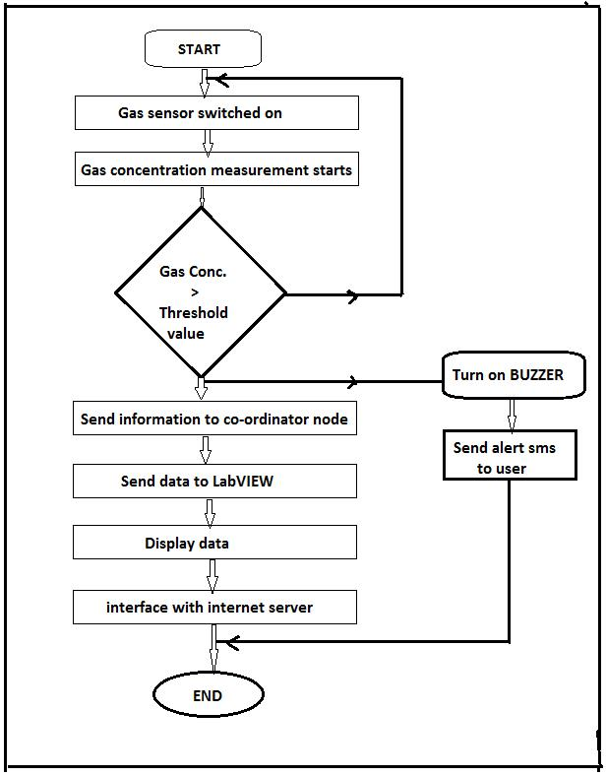

**Flowchart of the wireless gas sensing system.**

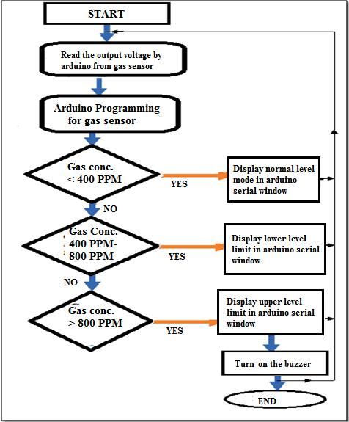

**Flowchart of arduino programming for LP gas sensor**

**CHAPTER 7:**

**MODULES**

**a) The gas sensing and the unit**

In this, a gas sensing apparatus to achieve the sensing mechanism is discussed.

**1. The gas sensing**

The device which converts physical quantity into electrical quantity is a sensor according to the Instrument Society of America. The different definitions and diverse views about the sensors have been adopted by scientists and engineers. Also sensor is a device which converts one form of energy into other form. Normally, the sensors are grouped according to their signals are received and generated [49]. The sensors are classified according to the energy generated or received by them. Sensors categorization is enormous field, can’t be classified on one criterion e.g., they are classified according to its relevance, the fabric and the property used by itself.

The sensors are active or passive in nature. To obtain and quantify the signal, passive sensor is used. An active sensor is used for measuring signals transmitted by the sensors that were reflected, refracted or scattered. Based on the transmission of signals, active or passive sensors are classified. The vital properties of sensors are summarized below.

* The time taken by the sensor
* How sensors are reproducible
* An aging effect of the sensor
* The sensitivity and stability possessed by the sensor
* dynamic range
* selectivity
* size, weight and cost.

The response time of a sensor is the time taken by the sensor to reach 90% of its steady state output value after the introduction of the measurand, whereas the recovery time is the time taken by a sensor to be within 10% of the value it had before the exposure to the measurand. The sensor with less response time and recovery time is considered to be a good sensor. The ability of the sensor to produce the same characteristic upon the repeated exposure to a particular measurand is referred to as it’s reproducibility. The sensor with excellent reproducibility will have the same recovery time, response time as well as the same response for a particular measurand. However, there is some degradation on the sensor signature after a long use of the sensor and it is natural. The time taken by a sensor for it’s degradation is commonly known as aging. Sensitivity and resolution are the critical properties of a sensor for the application with the precise measurement system or for the application sensing the potentially dangerous measurand. The smallest change in the measurand that a sensor can detect is the resolution of the sensor and the change in the output per unit change in the measurand is the sensitivity of the sensor. The importance of properties of a sensor depends on the application where the sensor has to be used. For example: In the detection of highly toxic gas, sensitivity is the important property, in online control system where the measurand is exposed repeatedly. Reproducibility and aging are the important properties wherein as application relating to the implantation of biosensor in the animals, weight and size becomes the important issues.

**2. The gas sensing unit**

The gas sensing unit is a cylindrical leak proof metallic (good quality stainless steel) chamber of volume around 250 cm3. It’s typical dimensions are 8.6 cm X6 cm. It is fitted on a metallic base of dimension16.5cm X 15 cm. The chamber was made leak proof using the metallic and rubber O-rings fitted tightly to the chamber by a screw arrangement. A provision was made for inletting the

calculated quantity of gas into the chamber by a metallic (S.S) capillary (I.D. ͠= 2

1. The electrical contacts were made to the sensor for the measurements and the sensor was placed inside the chamber. The measurements were made at room temperature (299K).

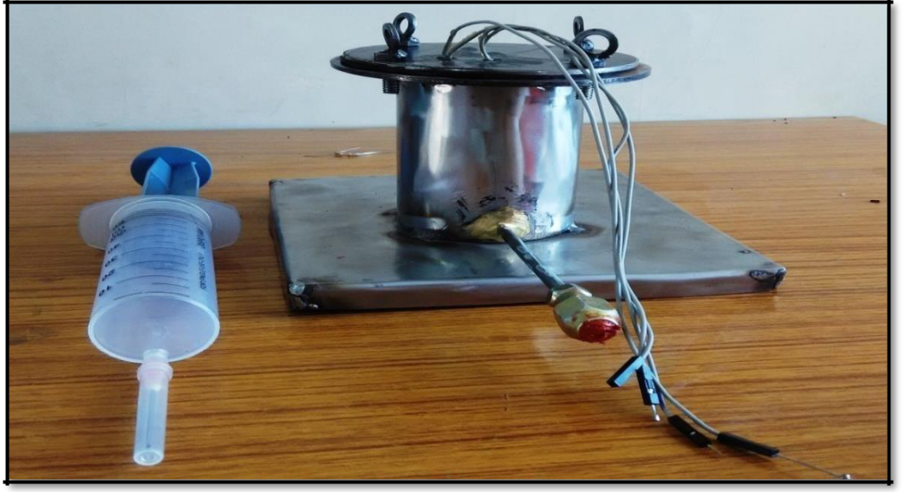

**Fig. 2.2. The gas sensing unit.**

**b) Circuit for the gas sensor**

The present wireless gas sensing system uses MQ-2 gas sensor for the detection of LPG gas [50]. It is an ideal sensor to detect the presence of a dangerous LPG leak in our home or in a service station, storage tank environment and even in vehicle which uses LPG gas as its fuel.

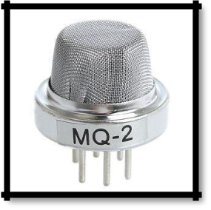

**Fig.2.3. MQ-2 gas sensor.**

This unit can be easily incorporated into an alarm circuit/unit, to sound an alarm or provide a visual indication of the LPG concentration. The sensor has excellent sensitivity combined with a quick response time. When the target combustible gas

60

exists, the sensor’s conductivity goes higher with the gas concentration rising. The gas sensor circuit diagram is shown in fig. 2.4.The three output pins of this sensor are VCC, GND and V0 pin. RL used in figure 2.4 is 20 KΩ. The load resistor (RL) is connected between heating coil terminal and one of the input pins.

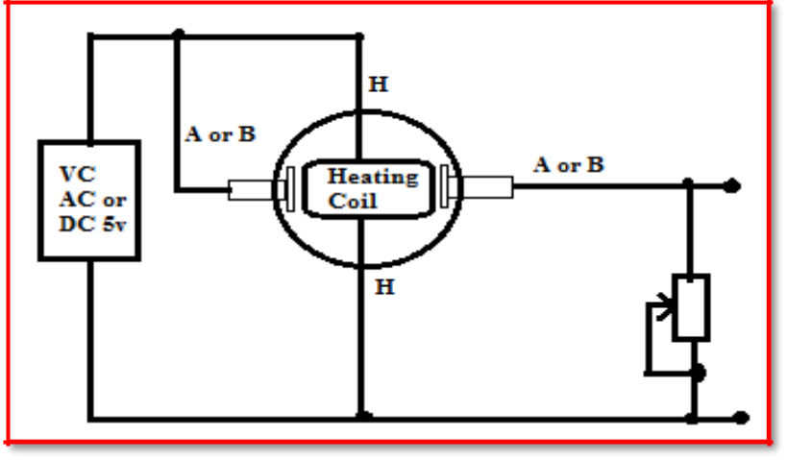

**Fig. 2.4. Gas sensor circuit diagram.**

The sensor’s resistance between Rs and RL form a voltage divider. Based on the data provided in the MQ-2 data sheet, Rs is determined in the clean air under given temperature and humidity constant. The fig. 2.4 also shows the sensor out come with 6 pins. The coil of the gas sensor is shown by pin H. The connection between pin A and B to the sensor is shown in fig.2.4.

Figure 2.5 below shows the gas sensor connection to the arduino pins. The sensor is connected to analog pin A0 of arduino, read the output in the form of voltage from the sensor respectively. For stable operation of sensor the more heating of the coil is required.

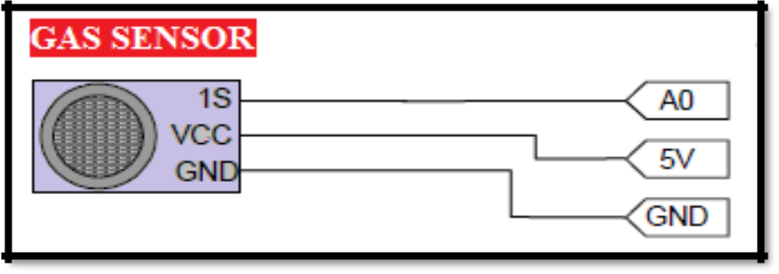

**Figure 2.5. The gas sensor connection to arduino pin.**

61

* + The coil of the sensor consumes more power.
  + To operate the senor 5 V is required.
  + The arduino gets powered through its jack available on board itself.

1. **The output circuit connection of wireless gas sensing system**

It consists of the following hardwares:

1. The connection of buzzer to the system
2. The exhaust fan connection and
3. The ZigBee connection.

The purpose of the above hardware is to alert, prevention of accidental attacks and wireless communication among the motes. The alerting to the users is possible only after the gas concentration beyond the towering concentration. The threshold level limits with respect to sensor output voltage is shown below.

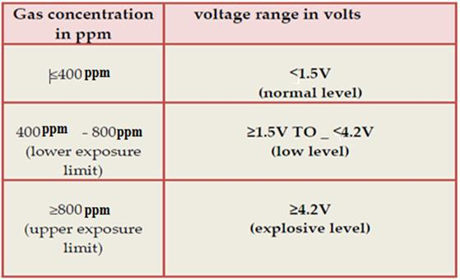

When the gas concentration is beyond 800 ppm, start buzzering to alert the users that the neighboring areas have entered in hazardous situation and tragedy emigration is needed. When the gas attention reaches between 400 ppm- 800 ppm the fan will turn on to indicate the caution stage and it sucks out the gas outside the leakage area as the precautionary measures against explosion attacks.

62

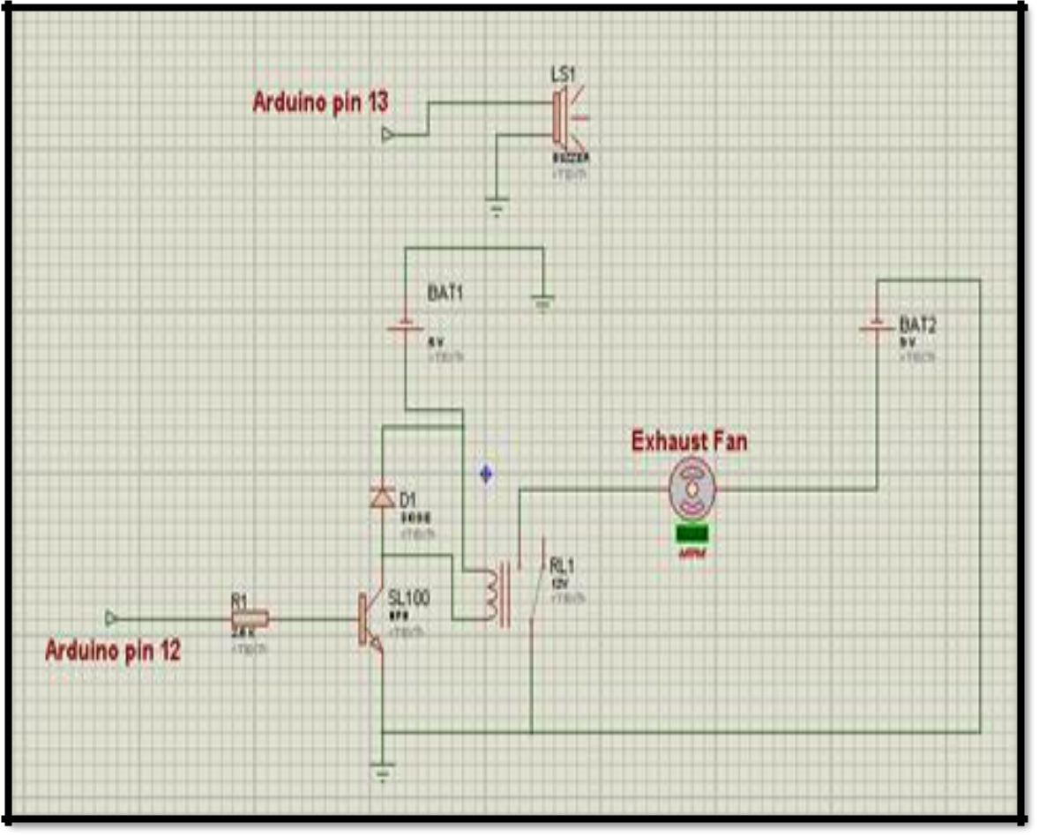

**Fig.2.6. The hardware connection circuit.**

Figure 2.6 shows the hardware connection circuit which shows the buzzer and exhaust fan connection to arduino. The arduino pin 13 is connected to alarm system and exhaust fan connection to arduino pin 12. The transistor SL100 is used as bridge between controller and fan because operating voltage of both is different. Here, the relay provides a 9V to the exhaust fan. Before installing the entire circuit, Relay should be checked whether it is normally open or closed. After getting the signal from arduino pin, the exhaust fan is turned because it is in normally open mode. Lastly, the hardware circuit from the arduino is connection of ZigBee. The ZigBee connection to arduino is shown in fig.2.7. The data from the sensor nodes is transferred to gateway node using ZigBee, interfaced with LabVIEW for monitoring of the data.

63

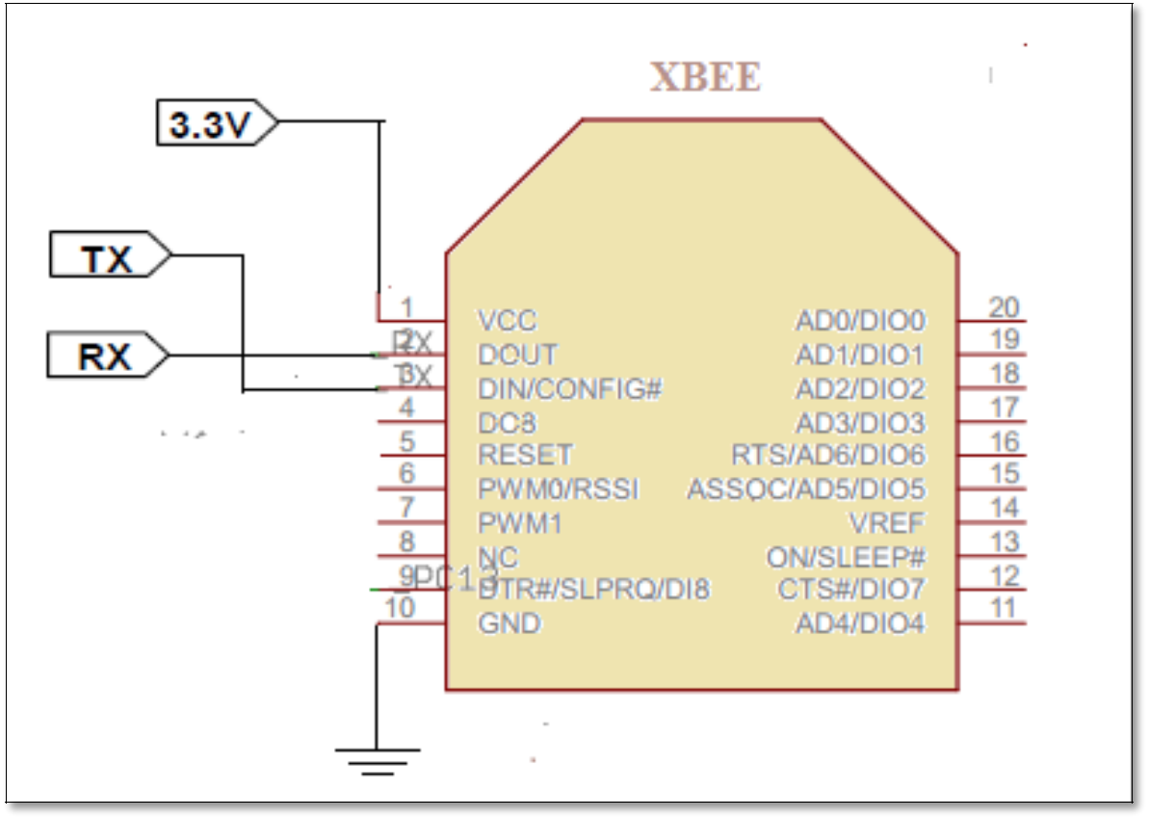

**Fig.2.7.ZigBee output diagram.**

**2.3.3 The development of PCB for the system**

The final step of the hardware part is the PCB development of the system. The PCB is designed with the Express PCB software package. This software is especially used for PCB design. For the PCB development, copper clad or PCB board is used. The bread board connection was installed first before developing the entire PCB. Copper clad board provides permanent connection among the components; they can remove only after de-soldering it. For providing the permanent connection soldering is effective method. As well, banana pins was used as a jumper wires.

**2.3.4 Power supply unit for wireless sensor node**

Our system works on +5V power supply in which microcontroller and LPG sensor work. The XBee unit requires (for RF communication) +3.3 V [51-52]. For establishment of wireless gas sensing system, the WSN nodes should be located at

specific locations within the room. To deploy these WSN nodes, at different places, it is essential to provide battery back-up. Therefore, the deployment of DC rechargeable batteries is made. Each node is associated with its own battery of 12 V. The WSN nodes consist of XBee unit which consumes rather high power. Therefore, it is essential to charge these batteries frequently. It is observed that, batteries could be used for 09 hours in continuous mode. The power supply unit for WSN node is shown fig.2.8.

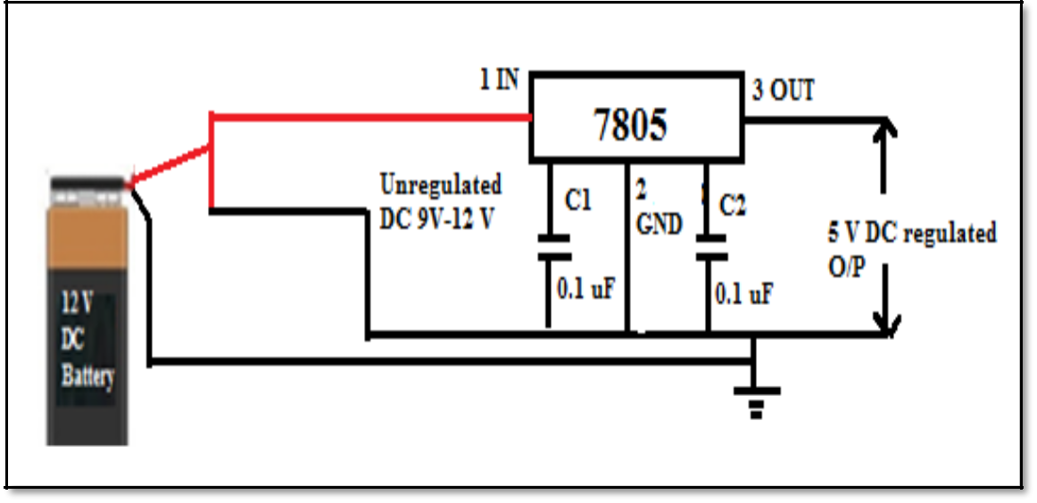

**Fig.2.8. Power supply unit for wireless sensor node 2.3.5 The hardware components for co-ordinator node**

The receiving section consists of a co-ordinator node and a pc or laptop. The co-ordinator node of a wireless sensor network has the same structure as that of the sensor node except sensor module. It is responsible for establishment of the network, information reception, aggregation, processing and sending control instruction and implementation. The coordinator node has ZigBee module to receive the information from the sensor node and send it to the arduino microcontroller. The microcontroller sends this collected data to the PC using a USB cable to update the values of monitoring sites in the PC. Using a single co-ordinator, a network with four sensor nodes is developed. The co-ordinator node communicates the sensor node through the GSM modem.

It consists of: a) XBee module b) Arduino Microcontroller c) Arduino GSM shield d) Buzzer e) Power supply unit.

**a) The XBee module**

The ZigBee device is programmed as a co-ordinator using X-CTU IDE tool as described in chapter I. It includes the networking and security, RF interfacing, serial interfacing, I/O settings, diagnostics, and AT command options [53]. The ZigBee works with IEEE standards. The co-ordinator XBee module extracts data from the transmitter module and sends to the PC through arduino controller.

**b) An arduino board (ATmega328 microcontroller)**

An arduino UNO is used; serial communication is possible easily because of integrated USB facility [54]. The board posses 2K RAMS. In addition, the logical decision regarding to alert and control is done using it. The XBee is able to perform any application without microcontroller, it is optional. But it can’t take any logical decision like microcontroller; only fruitful wireless communication is possible. To carry out these restricted decisions arduino UNO microcontroller is used at the sink or gateway node. Beside this, compatibility of GSM shield for sending SMS on user mobile phone, least power makes these most favorable than available controller in the market. Also, it provides compatibility with other shields available with Arduino which makes it enormously adaptable and accessible.

**c) The GSM module**

The Arduino GSM shield is a compatible to UNO board, therefore used to send alert SMS on user mobile phone after detecting the gas leakage. The shield is programmed using arduino IDE [55]. The programming is done using AT commands [56]. The SIM card from GSM mobile is only applicable. The connection of shield pins 2 and 3 is given to an Arduino UNO. Pin 2 is connected to TX of the UNO’S and vice versa.(fig. 2.9).

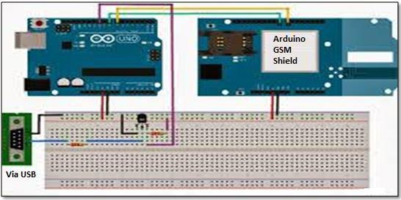

**Fig.2.9. Arduino GSM connection to Arduino UNO board.**

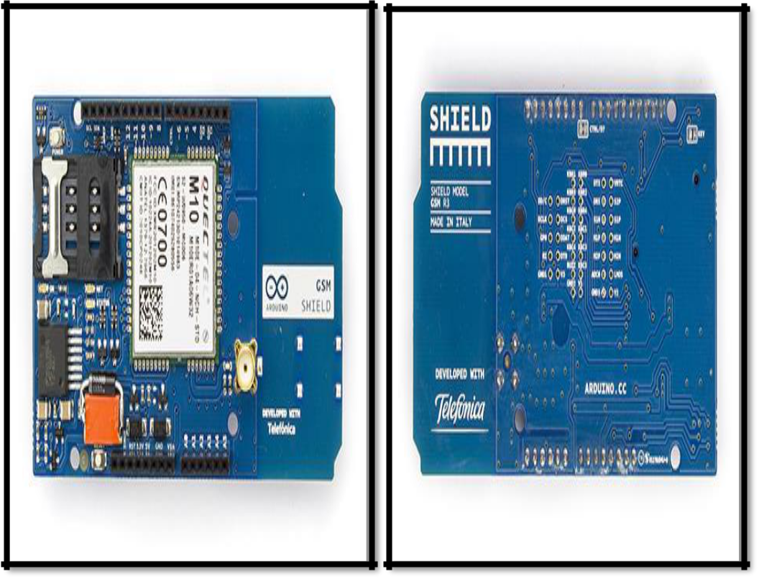

**Fig. 2.10. An Arduino GSM shield: front and back view.**

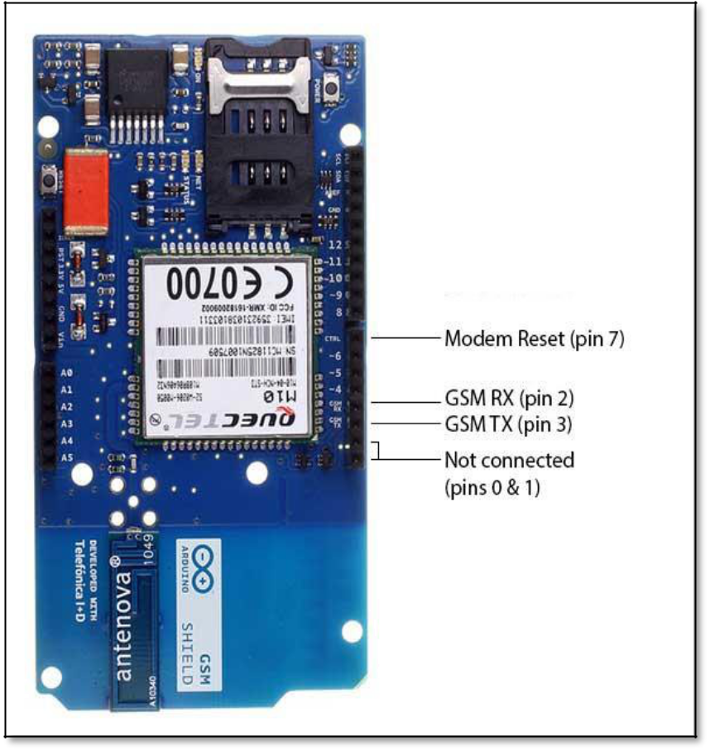

.

**Fig.2.11.Connection of GSM Shield to the arduino UNO.**

**d) The buzzer**

The buzzer is used as an acoustic signaling device. It is used for alerting the peoples in the form of alarms, as timers for various applications. We proposed a buzzer having piezoelectric element. The buzzer is ON only after getting the signal from the microcontroller. When the gas concentration goes beyond its explosive limit, the alarm circuitrary works.

**e) Power supply unit**

The co-ordinator node consists of XBee unit, which requires 3.3V, given from arduino board having on board 3.3V supply. An arduino gets power from its USB cable. The power supply unit for co-ordinator is shown in fig.2.12.

68

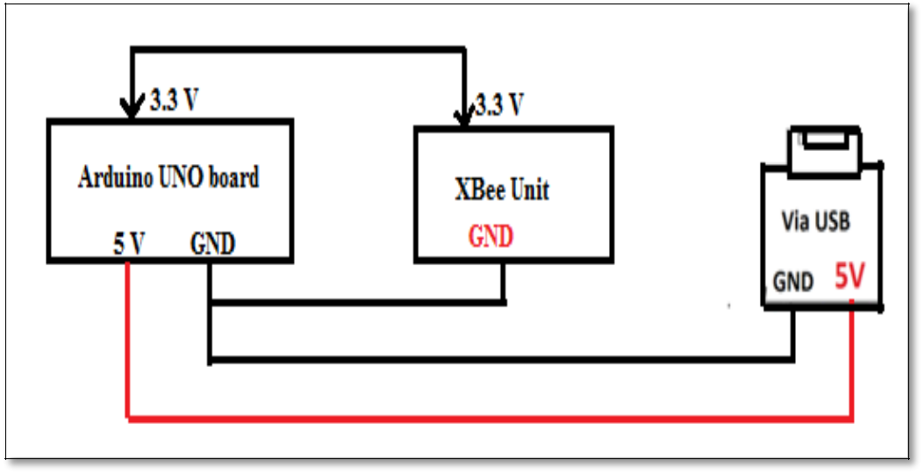

**Fig.2.12. Power supply unit for co-ordinator node.**

**2.3.6 The PC/Laptop for visual interpretation**

The PC/Laptop is connected to co-ordinator node for visual interpretation. The coordinator node allows data collection over ZigBee, and result will be displayed on the laptop. The monitoring of the data is done on it.

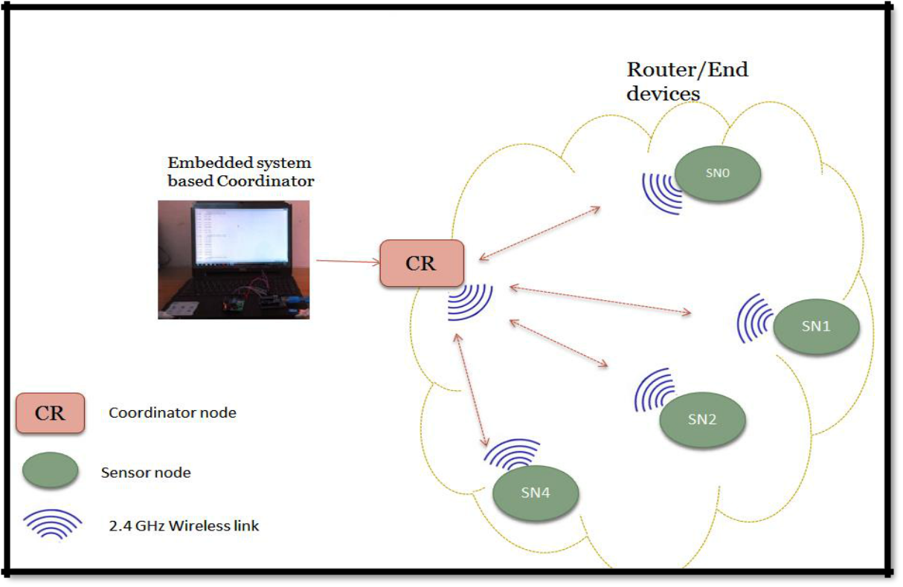

**CHAPTER 8:**

**SCREENSHOTS**

**CHAPTER 9:**

**SOFTWARE REQUIREMENTS**

**CHAPTER 10:**

**CODING**

**Main Program**

The program for LPG gas leak detection monitoring and controlling is done as follows.

**\*The program listing\***

******************************************************************

*************************************************************

//* Program created 25 Feb 2014 by Mujawar T.H */

115

****************************************************************** **************************************************************

#include <GSM.h>

#define PINNUMBER " "

GSM gsmAccess;

GSM_SMS sms;

int time=1;

int count=0;

constintanalogInPin = A0;

int buz=13;

int solenoidpin=11;

intfan=12;

intsensorValue = 0;

float voltage;

unsigned int interval = 100;

Char phone_no [ ] = "xxxxxxxxxx";

Char message [ ] ="gas leakage, Kind Attention";

void setup ()

{

* initialize the Sensor pin as an input: pinMode (sensorValue,INPUT);
* initialize the relay pin as an output: pinMode (solenoidPin, OUTPUT);
  + initialize the fan pin as an output: pinMode (FanPin, OUTPUT);

While (! Serial)

{

; // wait for serial port to connect.

}

Serial.println("SMS Messages Sender");

// connection state

boolean notConnected = true;

* Start GSM shield
* If your SIM has PIN, pass it as a parameter of begin() in quotes While (notConnected)

{

if (gsmAccess.begin(PINNUMBER) == GSM_READY)

notConnected = false;

else

{

Serial.println("Not connected");

delay(1000);

}

}

Serial.println ("GSM initialized");

Serial.begin(9600);



/* Calibration of sensor*/

Void loop ()

{

int sensorValue = analogRead(A0); // read the input on analog pin 0:

* Convert the analog reading (which goes from 0 - 1023) to a voltage (0 - 5V): float voltage = sensor Value * (5.0 / 1023.0);

Serial.println(voltage); // print out the value you read:



//*Normal level of gas leakage*//

if (voltage <=1.5 )

{

//"gas detected" message will be displayed in serial monitor Serial.println (" LPG DETECTED in normal level mode.");

delay (1000);

}



//* Warning of gas leakage*//

if (voltage >=1.5&& voltage <=4.2)

{

//"gas detected" message will be displayed in serial monitor”// Serial.println (“LPG DETECTED in lower level limit.");

delay(1000);

}

******************************************************************

* * Explosive level of gas leakage*// if (voltage >=4.2)

{

//"gas detected" message will be displayed in serial monitor”// Serial. Print (“LPG DETECTED in upper level limit."); Serial.println (“Explosive level of gas leakage.");

tone (buzzerPin,2500,interval); //Ring the buzzer when there is a gas leak detection

digital Write (solenoidPin, HIGH);// turn the solenoidPin on (HIGH is the voltage level)

Serial.println (" Solenoid switch is pressed: close");

delay (2000); // wait for a second

digital Write (solenoidPin, LOW); // turn the Pin off by making the voltage

LOW

digital Write (FanPin, HIGH); // turn the FanPin on (HIGH is the voltage level)

****************************************************************** //* Sending SMS to the user *//

While (count <time)

{

delay(1000);

Serial.println(phone_no);

* sms text Serial.print(message); Serial.println("SENDING"); Serial.println(); Serial.println("Message:"); Serial.println(message);
* send the message sms.beginSMS(phone_no); sms.print(message);

sms.endSMS();

Serial.println("\nCOMPLETE!\n");

}

else

{

Serial.println(" no gas leakage");

delay(1000);

}

}

}

******************************************************************

The arduino programming for these is done as follows.

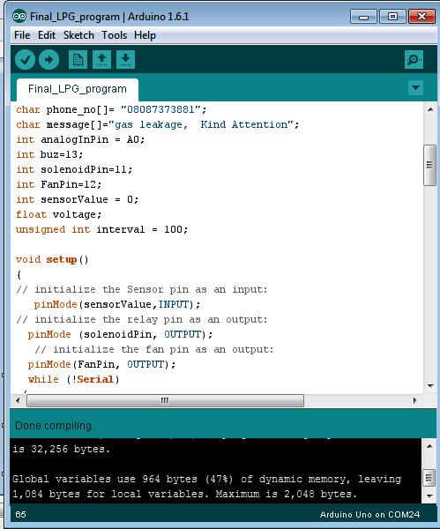

**CHAPTER 11: APPLICATION AREA**

**CHAPTER 12: FUTURE SCOPE**

**CHAPTER 13:**

**CONCLUSION**

The recent proliferation of small and low-powered hardware platforms that integrate sensing, computation and wireless communication has led to the widespread interest and utility in the design and development of wireless sensor networks (WSN). Such networks have key role applications in a variety of sectors such as medical, industry, military, defense, surveillance, home, etc. Wireless sensors allow otherwise impossible sensor applications, e.g. monitoring dangerous, hazardous and unwired remote areas and locations. The technology provides nearly unlimited installation flexibility for sensors and increased network robustness. Furthermore, wireless technology reduces maintenance complexity and costs. WSN’S allow faster deployment and installation of various types of sensors because many of these networks provide self-organizing, self-configuring, self-diagnosing and self-healing capabilities to the sensor nodes. Some of them also allow flexible extension of the network. Most wireless sensors have signal conditioning and processing units installed at the location of the sensors and transmit signals in the digital form. As a result, noise pick-up becomes a less significant issue. Moreover, since wire connections are deleted from the transreceiving processes, reliability of the signal transmission and receiving is enhanced.

On investigation, it is found that various wireless standards have been established. Among them, the IEEE 802.15.4 (ZigBee) are used more widely for measurement and automation applications. These standards use the instrumentation, scientific and medical (ISM) radio bands. The 2.4 GHz band has a wider bandwidth that allows more channels and frequency hopping and permits compact antennas.

sensors and monitoring systems, have many shortcomings**:** a long deployment time, high maintenance cost, dependence on cable telemetry systems, the inability of cables to resist to various damages, as well as large demand in cable supplies. In addition, in remote places, power supply may not be available to implement the monitoring system. Therefore, the present research work was carried out using a WSN to replace incompatible wired network systems. Moreover, the advanced microcontrollers with low power consumption are available to make smart WSN nodes. Taking the above facts into account and considering out laboratory limits, it was proposed to design and develop a system that would be able for reliable communication without the use of wired instrumentation and process control. Accordingly, we have chosen a system, ”Development of Wireless Sensor Network for Hazardous Gas Leakage Detection and Alert System**”,** the objectives of which are to design and develop a suitable system and methodology that can detect presence of a natural LPG gas and send SMS alert to the end user. The design of system being dynamic, monitoring and controlling is also of importance. The system was designed and implemented for the detection of a natural LPG gas. The results of implementation are interpreted adequately. In actual, we have proposed the deployment of ZigBee technology to ensure wireless communication needed to establish a Wireless Sensor Network. To emphasize the ZigBee technology, an architectural details regarding ZigBee device and its programming are extensively studied and given in chapter II .On comparative studies of various wireless technologies, it is found that the ZigBee technology is most suitable and plays a commendable role in the development of Wireless Sensor Network [4-6].According to the architecture; there are two groups of ZigBee devices; the ZigBee series 1 and ZigBee series 2. For our studies series 2 devices were employed. Employing a highly sophisticated IDE, “The X-CTU”, the ZigBee devices are programmed in the desired mode. Therefore, the salient features of this IDE have been studied and understood thoroughly. The programming tool, “XBee and5) This system is built for the purpose of life-saving that many people in a wide range of industries rely on the alert to them.

**Future Implementations**

1. The LPG gas release/detection alarm system safety features can also be improved by adding another function to check the sensor’s condition in case the sensor is not working properly or if the sensor’s calibration has been displaced/ deliberately changed.

1. In near future, our motto is to add automatic windows opening system application when the gas leakage is detected within the room / home.
2. To implement android apps.

**CHAPTER 14:**

**REFERENCES**

1. Arduino. [Online]. Available: <http://arduino.cc/>
2. A. Manjhi, S. Nath and P .Gibbons, “Tributaries and deltas: Efficient and robust aggregation in sensor network streams”. SIGMOD, 2005.
3. L. Ni, Y.Liu, Y.Lau and A.Patil, “LANDMARC: Indoor location

sensing using active RFID”, Wireless Networks, 10 (2004).

1. I. Solis and K. obraczka, “Efficient continuous mapping in sensor networks using isolines”, Mobiquitous, 2005.
2. X-CTU Configuration and Test Utility Software: User’s Guide, Digi
3. L. Liu, Z.Wang and Y.X Sun, “Survey on Coverage in Wireless Sensor

Networks Deployment”,Journal of Electronics & Information Technology,28(2006) 1752-1757.

1. Z. Fang, Z.Zhao, P. Guo, and Y.G.Zhang, “Analysis of Distance Measurement Based on RSSI”, Chinese Journal of Sensors and Actuators,20(2007) 2526-2530.
2. C.H. Wu and Y.C Chung, “Heterogeneous Wireless Sensor Network Deployment and Topology Control Based on Irregular Sensor Model”,

Advances in Grid and Pervasive Computing, 4459(2007) 78-88.

1. G.Zhou, T.He, S. Krishnamurthy and J.A.Stankovic, “Models and

Solutions for Radio Irregularity in Wireless Sensor Networks”,ACM Transactions on Sensor Networks (TOSN), 2(2006) 221-262.

1. T.H.Mujawar, V.D.Bachuwar, M.S.Kasbe, L.P.Deshmukh, ”Wireless sensor network system: gas leakage detection and monitoring” IJCR, 7(2015) 18445-18450.
2. T.He, C.Huang, B.M Blum, J.A. Stankovic, and T. Abdelzaher, “Range-

Free Localization Schemes for Large Scale Sensor Networks”,

Proceedings of the 9th Annual International Conference on (MobiCom-2003), San Diego, September 14-19, pp.81-95.

1. L. SeongPeng and G. H. Yeap, “Centralized Smart Home Control System via XBee Transceivers”, ISBN: 978-1-4673-0020-9, IEEE 2011.